1999 USA Pan Am Softball Team Ontario Tour
“VERY RARE FOR SOFTBALL FANATICS”
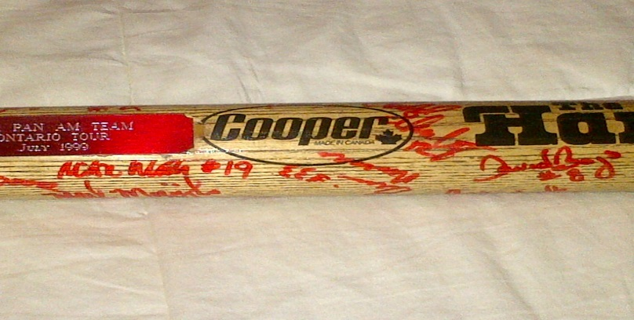
All signed by the whole team, roster is as follows….
Denny Bruckert - Head Coach
John Becker - Asst. Coach
Jimmy Moore - Asst. Coach
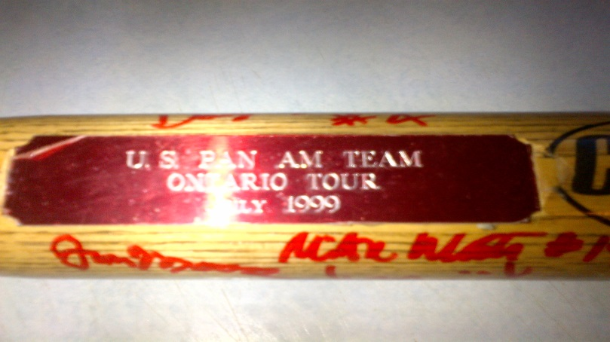
Steve Padilla - Asst. Coach
Chris Bigelow
David Boys
Chris DeLarwelle
Ehren Earlywine
Anthony Farinacci
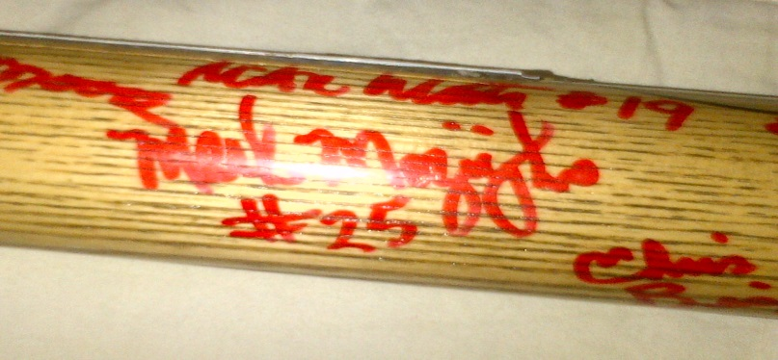
Barry Kahler
Steve King
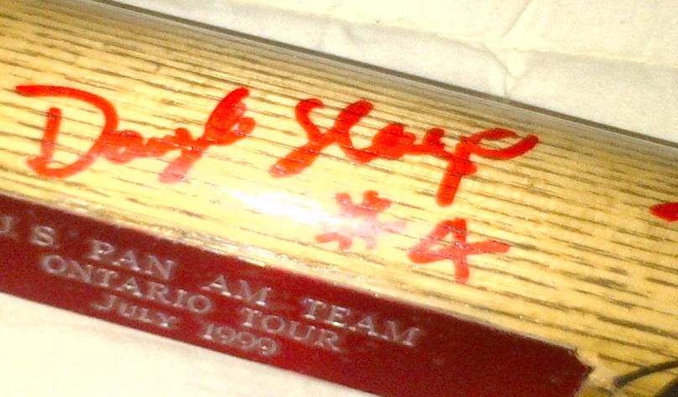
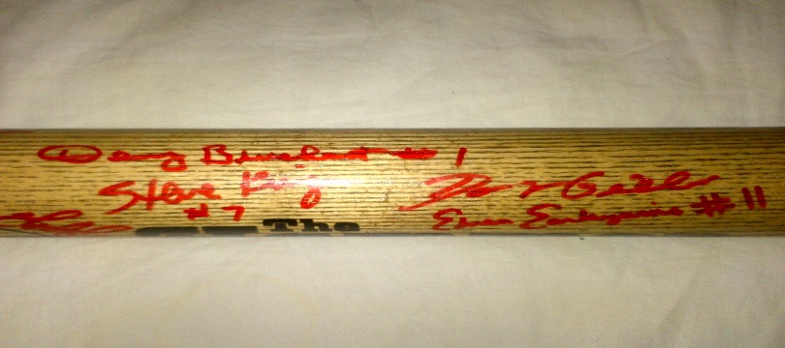
Brian Martie
Doug Middleton
Thomas Montgomery
Brian Neveau
Shawn Rychcik
Doug Sleep
Tim Wahl
Mike White

This bat is up for sale if you’re interested in it or know someone
please contact me at leuszler@oemeta.com

